GNOMELAND

A letter has just arrived from the Head Gnome asking your help to plan a new Gnomeland for a group of Gnomes to live in.
The letter says:

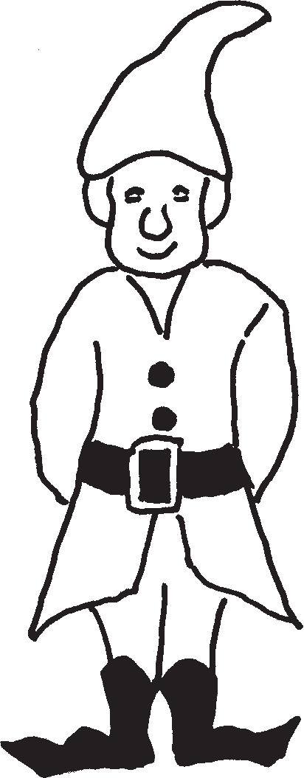
Dear Children,
The Gnomes need 12 homes, all with 4 rooms.
They would like all the houses to be different. Using cubes, show how you would make the homes. Here are a few possible homes.

- 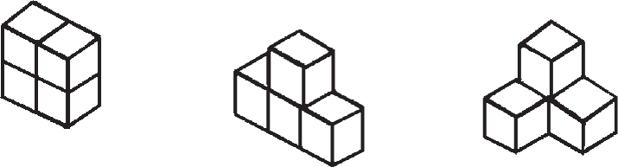

Design as many gnome homes as possible. There are lots. Use cubes to build each home.
Kind regards,
Head Gnome.
The Mayor of Gnomeville decides to pay the village a special visit so the gnomes decide to paint their houses.

Each square face costs £10 to paint. Each gnome has to work out how much it will cost to paint his house.

- How much does each of your houses cost to paint?
- Which is the cheapest?
- Which is the most expensive?

When the Mayor arrives, he announces that he is putting a tax on the gnomes’ homes. Each gnome has to pay a ground rent of £20 for each square that covers the ground.

- How much does each of your gnomes have to pay?
- Who has the cheapest ground rent?
- Who has the most expensive ground rent?
- If you take both the painting and the ground rent into consideration, which of the gnomes has to pay the most? And who has to pay the least?

The gnomes decide they all want gardens. Each garden must be made up from 12 squares, all the same size.

- How many different gardens can you design and draw?

The gnomes decide to put fences around their gardens. The fencing costs £10 for a length that fits along one side of the squares.

- How much does each gnome have to pay for fencing?
- Who has to pay the least?
- Who has to pay the most?
Teachers’ notes

Equipment needed:
Multilink cubes.

You will need to decide whether reflections and rotations count as different designs. The concept of congruence could be introduced if appropriate.

