How much do I know?

3. Geometry

Try this first:

The diagram shows a shaded triangle inside a rectangle.

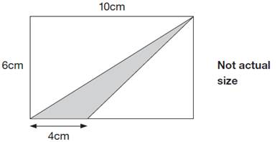

What is the area of the shaded triangle?

Answer:

12 cm² (see next page for explanation)

What is this topic?

Geometry (or Shape, Space and Measures) covers the following topics:

- Measurement: mass, weight, volume, capacity, length, time, metric and imperials units.
- Angles: degrees; types of angles: acute, right, obtuse, reflex; the sum of the angles in a triangle (180⁰) and in a quadrilateral (360⁰).
- Transformations: translation, reflection, rotation, enlargement, scale factors.
- Reflection and rotational symmetry
- Two-dimensional shapes: triangles (equilateral, isosceles, scalene, right-angled), quadrilaterals (square, rectangle, parallelogram, rhombus, trapezium); polygons and regular polygons; circles.
- Three-dimensional shapes: cubes, cuboids, prisms, pyramids.
- Coordinates in all four quadrants.
- Perimeter, area and volume of 2D and 3D shapes.

Children often get confused about the difference between perimeter and area. Perimeter is the DISTANCE or LENGTH round the boundary of a 2D shape (“if you were an ant, it would be the distance you would crawl all around the edge of the shape”). Area is the SPACE inside a shape. There are lots of activities to reinforce these concepts (e.g. Gnomeland and Rectangles).

The basic formulas for area are:

- Area of a rectangle = base x height (or length x width)
- Area of a triangle = ½ base x height (or base x height $÷$ 2)

Some shapes are composite shapes, which need to be split up into their basic elements (rectangles/triangles). There is often more than one way to do this.

In the example above, we have a rectangle and a triangle.
We can either use the triangle area formula directly to find the area of the shaded triangle. The base is 4cm and the height is 6cm (note that in this case the height is NOT one of the sides of the triangle; the height is always at right angles to the base). So the area is: 4 x 6 $÷$ 2 = 12 cm².

Alternatively, you could work out the area of the whole rectangle and then subtract the areas of the two unshaded triangles. These are both right-angled triangles, so the height IS one of the sides.
Area of rectangle = 6 x 10 = 60 cm²
Area larger triangle = 6 x 10 $÷$ 2 = 30 cm²
Area smaller triangle = 6 x (10 – 4) $÷$ 2 = 18 cm²
So area of shaded triangle = 60 - 30 – 18 = 12 cm²

Questions

Q1. Here is a square on coordinate axes.
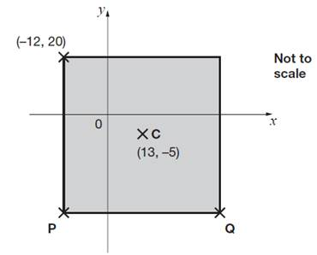
C is the centre of the square.
Find the coordinates of P and Q.

Q2. Here is a model made from 10 cubes.

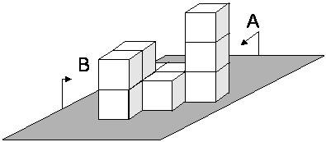

From direction B, the model looks like this.

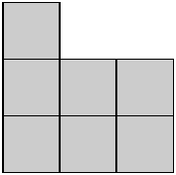
On the grid, draw how the model looks from direction A.

Q3. Triangle ABC is equilateral.
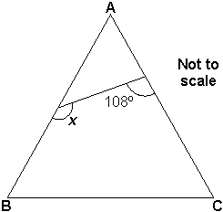

Calculate the size of angle x.
Do not use an angle measurer (protractor).

Q4.The following quadrilaterals all have a perimeter of 36cm.
Here is a table to show the length of each side.

Complete the table.
One quadrilateral is done for you.

 |  |  | Side lengths
 |  | square | 9cm 9cm 9cm 9cm
 |  | rectangle | 3cm
 |  | rhombus | 9cm
 |  | kite | 10cm

Answers

Q1. P is (-12, -30) and Q is (38, -30)

Q2. 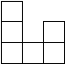

Q3. 132⁰

Q4.
square | 9cm | 9cm | 9cm | 9cm
rectangle | 3cm | 15cm | 3cm | 15cm
rhombus | 9cm | 9cm | 9cm | 9cm
kite | 10cm | 10cm | 8cm | 8cm

Do you need more information?

Refer to Mathematics Explained for primary teachers by Derek Haylock, Section D, pages 275 to 328.

