Playful number recognition and ordering

Use your set of cards 1-20.
- Ask your child to put the cards in order and then shut their eyes.
- Turn over one of the cards. When they open their eyes, can they tell you which card is turned over? (If 20 cards feels to many for your child then use cards 1-10 until they are ready for more.) Now you close your eyes and they turn the number over for you to guess.
- Now take it in turns to try the same thing but with the numbers jumbled up!
- Ask your child to put the cards back in order and shut their eyes.
- Swap two cards around. Can they put them back in the right order? Now close your eyes and your child swaps two cards for you to guess.
- Jumble up the cards. Now hide one (or two). Can your child find the missing card(s)?
- Put the cards back in order and take it in turns with your child to ask questions about the order of the cards:
Which number comes after 2? 17? 9?
Which number comes before 7, 11, 19?
Choose a number and ask: which number is one more than e.g.11
and which number is one less than e.g. 19
- Pick up a card and show it to your child with the challenge :
Jump this many times Go and collect this many biscuits
(choose your number carefully for this one!!)
- Shuffle a set of number word cards for the numbers 1-20 and turn one over. Ask your child to find the matching numeral card. Swap roles and do some more matching!

Counting in Year One
In school children will be practising counting, reading, and writing numbers from 0-100 in numerals and from 1 to 20 in words as well. They will be counting forwards and backwards and in 2s, 5s and 10s.

Talk Maths Talk: Parents Supporting Learning in Maths

Counting for confidence and fluency
Counting out loud in as many different ways as possible is a good way to make sure that your child is confident and flexible with numbers.
Enjoy being playful when counting together.
Take it in turns to lead the counting and to set the next counting challenge. Give your child plenty of thinking time and encouragement.

Emphasise the sounds, rhythm and pattern.

Enjoy counting rhymes and books together: try We All Went on Safari by Laurie Krebs www.barefootbooks.com
This book also helps children to develop a sense of ordinal number: first, second, third, fourth by discussing which animals the family meet first, second, third and so on…
Handa’s Surprise by Eileen Browne and published by Walker paperbacks is another good book for ordinal number and there’s a definitely a surprise ending! You can watch Handa’s Surprise on You tube as well.

Try to do some counting twice a day!

Playful counting: clapping games
- Clap and count together from 1 to 10 then 1 to 20
- You clap and count to 3 then your child carries on counting – you join in at different times – go up to 20 (or more if your child would like to)
- Clap and count backwards together 10,9,8,7,6,5…
- Clap and count every other clap 2,4,6,8,10,12…20
- Clap and count every other clap 1,3,5,7,9,11,…20…this one is hard! You may want to whisper the other numbers to help.
- Clap and suddenly start counting!
- You clap and your child counts in their head and when you stop clapping they shout out the number of claps!

All of these games can be repeated but instead of clapping try
Clicking your fingers or tapping your nose or…?

Practising counting: wrapping paper

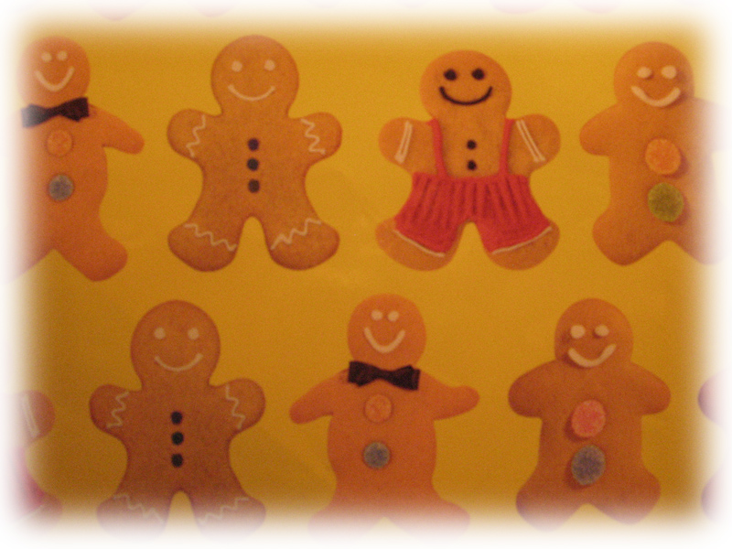
Looking at a strip of wrapping paper can help your child enjoy making some choices about what to count. Can you count the gingerbread people in 2s? Can you find two gingerbread people that are the same?
Can you find two gingerbread people that have only one difference?
I’m going to count the gingerbread people with unhappy faces.
What are you going to count?

Half a sheet of wrapping papers can provide lots more practice in counting different sets of things. First enjoy looking at and talking about the paper together: saying what you see. Then begin to focus on counting by using the how many? question – take it in turns to challenge each other to count something on the paper.

How many red stars can you see?
How many stripey stars can you see?

How many small purple stars can you see? How many large purple stars can you see?Are there more spotty stars than yellow stars?
Put a piece of string around some stars and ask:
how many stars inside the string?
how many stars outside the string? Are there more stars inside or outside the string? How many more?
Take it in turn to move the string and repeat the questions.
Find the numeral and word cards for the number of stars each time.
Then try it the other way round: show your child a numeral (use different styles of numerals) and ask them to put the string around that number of stars (or whatever objects you have on your wrapping paper!) Check together by counting out loud – this is a good work habit.

Practising counting: enjoying stories

Children love to revisit the same story time and time again which gives lots of opportunities to practise counting as well as other mathematical words.
First enjoy reading the story together. Then choose one or two of the pages and look for things to count and talk about together. Take it in turns to challenge each other to count a particular set of things.
Practise using the questions how many? how many more? how many altogether?
Sometimes there might be too many things to count one at a time and so you can talk about counting in different ways (2s, 5s and 10s) to make the counting manageable. You may also need to talk about how you will track which things have been counted and which ones still need to be counted and together you can come up with a strategy for being systematic – all good work habits.
Some books that your family might like:
Can You See Sassoon? By Sam Usher
Eat Your Peas by Kes Gray & Nick Sharratt published by Red Fox
Dinosaurs in the Supermarket by Timothy Knapman & Sarah Warburton published by Scholastic
Harry and the Bucketful of Dinosaurs by Ian Whybrow & Adrian Reynolds published by Puffin

Practising counting: in our heads
Games linked to Harry and his bucketful of dinosaurs can also be used to encourage your child to reason and to hold numbers in their head for calculating. They will need to listen carefully in order to count the number of dinosaurs being dropped into the bucket and you can then add 1 more and ask: how many now? How do you know?
They may need some help with giving an explanation and so work together on this and don’t worry if it takes a while for them to be able to answer the how do you know? question – it can be hard to explain our thinking out loud no matter how old we are! There can also be several different right answers, for example:
How do you know there are 7 in the bucket?
Because you added one more to 6 and 7 comes after 6
Because I know that 6 plus one is 7
Because I counted 6 then 7.

